Asphalt Surveillier
978-1-7281-4514-3/20/$31.00 ©2020 IEEE
An Intelligent road condition monitoring system

Subhankar Bhattacharyya
Dept. of Computer Science and Engineering
Institute of Engineering and Management,Kolkata
(subhankarbhattacharyya1007@gmail.com)

Abstract— Autonomous Drive (AV) and drive assist systems promises a safe, comfortable and efficient driving experience with decreased chances of road accidents. Substandard road conditions, inefficient transport infrastructure, potholes, deconstructed asphalts, poorly coalesced speed breakers and down-and-out drainage system on the roads are a cause of increasing accidents, driving discomfort, traffic jam are also one of the key roadblocks for implementing AVs in India.
The present idea discloses a road condition monitoring system, the method comprising sensor network and image acquisition system with implementation of machine learning algorithms. To provide meaningful input to vehicle control and acquire widely overlapping view a multi-sensor scheme using camera and LiDAR technologies are utilized which yield an ensemble of measurement positions clustered to the road surface obstruction further processed with a state-of-art image classifier. The whole monitoring and reporting system work in a threefold way. Depending on the distance of potential objects or non-uniformity of the road surface the controller either sends warning to the driver or becomes ready to take over the vehicle control by reducing speed or changing gears. Using gyro and accelerometer the measure of vibration caused during the drive will be classified to check the level of discomfort to assist in speed. And finally, to mitigate the accident risk or severe bad condition of the road beyond a certain threshold the controller can stop the vehicle considering propinquity of other vehicles and relative speed difference by IMU and proximity sensor. The proposed architecture model depicts how the sensor technology can be integrated with the transportation infrastructure to achieve a sustainable Intelligent Transportation System and ensure safety and driver assistance by decision making and action taking in addition to alerting driver on the verge of mistake.
Keywords—Drive Assist System, AV, Lidar, Image Processing, Topographical Surveillance, Drive Comfort, Safety, Sensor Network

Introduction
Humans are subject to human error and machines are subject to mechanical errors. We as engineers always try to balance between the two to get the best optimal result. In countries like India, roads are not uniform and in the desired condition and usually consist of pot holes which reduces driver experience and comfort. Driving Autonomous Vehicles (AVs) in such road conditions is a true deep learning challenge. The country, forecast to soon be the world’s third largest auto market, is loath to be left behind even as its chaotic roads and regulations create unique hurdles. This means in order to place AVs in Indian roads one has to account for pedestrians darting through traffic at will, multiple lanes that merge without warning, poor signage and stray cattle lingering on the roadside.
“Driverless cars for public use are at least 10 years away,” said Roshy John, a 17-year veteran in the field of robotics who heads that business at Asia’s largest IT services provider Tata Consultancy Services Ltd. He said the country’s challenges could provide the ultimate proving ground. “If it can work in India, it can work anywhere in the world.”
Having said that it doesn’t mean we stop looking for other alternatives till that day comes. A decade long is quiet a long time to wait for something to happen. Hence a solution to this is the main motivation of this paper
Firstly, in order to solve problems like these we need to realize to make our idea as economical as possible because we are talking about a country where economical tension is going to be a prolonged factor at any time so we need to look at the main basic problems and try to solve them as traditionally as possible and then build our way to the top. Take for an instance a washing machine, when it first hit the market there was just a stone and some washing powders, then came the same automatics to make the crowd comfortable with the new technological revolution and then once they got accustomed with the technology, fully automatic washing machines came into existence and hit the market with a boom. Here we need to do the same. In order to make the Indian masses get accustomed with AVs we first need to introduce semi-AVs that can use cheap sensors with economical ways of implementation.
One such way that we discuss in this context is the use of LiDAR images, motion and proximity sensors to alert the drivers of impending dangers in the road instead of expensive techniques of camera image processing and deep learning.

Problem statement

Problem statement :
In countries like India, roads are not uniform and in the desired condition and usually consist of pot holes which reduces driver experience and comfort. Existing electronics like IMU, GPS and ADAS systems may not be completely adopted to conditions like Indian roads where constructions and roads change frequently and using the solutions might be costly for smaller cars. even if the rules are changed to allow driverless vehicles, integrating them into city traffic will remain especially complicated in India. Roads can vary between modern highways and dirt tracks, with erratic street signage, a wide variety of vehicles and the occasional elephant or camel. For example: the ubiquitous, three-wheeled auto-rickshaw is rigged in so many different ways by its drivers that sensors struggle to identify its form, creating complications for machine learning algorithms.
So how do we use cost effective solutions? Top Priority Issues out of above-mentioned issues Desired Outcome Innovative solutions determining and classifying road scenarios for adaptive driving and comfort

Data :
Apart from the anarchy of its streets, developers in India have also given up a head start to global giants who are pouring billions into developing platforms. While Alphabet Inc., Uber Technologies Inc., Ford Motor Co., Baidu Inc. and Tesla Inc. have all invested heavily, nobody has yet developed a roadworthy autonomous solution.
At a secret testing track outside Bangalore, an arm of the Tata conglomerate is recreating the jumble of Indian roads to develop an autonomous driving system.
“Indian roads present a true deep learning challenge,” said Roshy John, a 17-year veteran in the field of robotics who heads that business at Asia’s largest IT services provider Tata Consultancy Services Ltd. John’s innovations are riding on sister company Tata Motors’ $3,500 Nano, touted as one of the world’s cheapest cars, while another unit of the group, Tata Elxsi, is developing the driverless platform.
“We are a couple of years behind the West in autonomous technology and both startups and large companies are racing to catch up,” said Sanjeev Malhotra, head of the Internet of Things Centre of Excellence, run by software industry body NASSCOM. “But adoption is another thing, there we are trailing far behind”. “After training and feeding hundreds of photos, our system cannot identify 15 percent of the vehicles on the Indian road,” said Nitin Pai, senior vice president and head of strategy and marketing at Tata Elxsi. “The driverless car is ready for the road. But is the road ready for the car?”
When John’s test car, a tiny white Nano hatchback, recently weaved its way through thin Sunday morning traffic in Bangalore at just 25 miles per hour, it still made frequent, jerky stops. As the car pulled up the required four meters short of the vehicle in front, irate drivers honked incessantly and yelled out abuse. A cow meandering into its path triggered another halt, as did the flinging of a massive banana stem out onto the road by a shop owner. As a limbless beggar wheeled his crude platform close, the car’s engine stopped abruptly.
Despite such indigenous efforts, global leaders in the autonomous race think driverless cars in India are a stretch. After weaving in and out of chaotic traffic during a visit last year, Uber co-founder Travis Kalanick told CNBC that India would be the last place on earth to get self-driving cars. “Have you seen the way people drive here?” he asked. On a visit a few months later, Google head Sundar Pichai agreed.

Autonomous driving or self-driving vehicle is a commonly used term these days and has become an integral part of the regular road-going cars in some way or the other. While by definition, an autonomous car is a vehicle that drives itself without any human intervention, there’s actually much more to the autonomous vehicles instead of just the self-driving component. Since autonomous driving depends on infrastructure and is capital intensive, automakers are using autonomous technology to make cars safer one step at a time. Also, autonomous car projects are largely contained in a closed environment during the testing phase, barring a few places like California, due to the safety hazards and ‘Liability Clause’. Here’s a low-down on autonomous vehicles, levels of autonomous driving and safety aspect of self-driving cars!
Although nobody in the world wants to get involved in an accident, the sad reality is, if you are driving a vehicle, you will get involved in an accident, no matter how small it is. Now when an accident happens, there’s generally a guilty driver behind it. But what happens in the case of an autonomous car? Who will be held responsible in case of an accident as there’s no one driving the car? This troubling question is looming over the governments and administrations from across the globe and nobody is able to find a global solution as of now. This scenario in autonomous vehicles is called the ‘Liability Clause’. Society of Automotive Engineers (SAE) has defined autonomous driving under various levels ranging from Level 0 to Level 5, depending upon the relation between a driver and vehicle. Here’s a brief explanation of each Level-
Level 0: While the driver of the car is in the full control of the vehicle, the automated system can issue warnings and may momentarily intervene (e.g. Lane driving system in Volvo XC60).
Level 1: Both the driver and the automated system shares the control over the vehicle. An example would be Adaptive Cruise Control (ACC) where the driver controls steering and the automated system controls the speed. Also, Lane Keep Assist where the steering can automatically bring back car in the lane if it leaves the lane without the driver’s notice. The driver can retake full control at any time.
Level 2: In Level 2, the automated system takes full control of the vehicle, including acceleration, braking, and steering. The driver can intervene if the system fails to respond properly. While it is often called the “hands off” form of driving, contact between hand and wheel is mandatory during SAE 2 driving.
Level 3: In this level of automated driving, the driver can actually turn the attention away from the vehicle and let it drive itself, while focusing on personal tasks. While any emergency situation can be well addressed by the vehicle itself, the driver must be prepared to intervene when called upon by the vehicle to do so. 2018 Audi A8 Sedan was the first commercial car to have level 3 self-driving.
Level 4: While the driver has to be awake and alert for any possible situation in the level 3, no driver attention is ever required for safety in the level 4, meaning the driver can go to sleep or leave the driver's seat.
Level 5: The last and final level doesn’t not need and human intervention and has no steering for control. An example would be a robotic taxi.

Countries like the U.S. are far ahead in the development of self-driving technologies and certain areas like California actually promote testing autonomous cars on public roads (although they have designated areas for the same). On the other hand, India is yet to experience the technology in its purest form and is only getting limited autonomous tech and that too in expensive cars. Players like Tesla, who have actually mastered this technology are not selling their vehicles in India.
Also, the government is not too keen on promoting self-driving cars in India as according to a recent statement by Nitin Gadkari, Union Minister for Road Transportation and Highways - there are 22 lakh drivers waiting to get jobs and driverless cars will hamper their prospects of getting a job. But we have to see a larger picture here! More than the jobs, autonomous driving has proved to be a life-saver in many cases (especially as seen with Tesla cars).
It is not about the autonomous vehicles, but the inclusion of autonomous technologies that will help reduce accidents and pave way for future of mobility!

Related Work :

article/pii/S0921889015302633[with reference to :1]

Highlights:
Curb information is used to divide pedestrian candidates into two classes, i.e., on-road and out of road.
Tracking aided recognition strategy is used to improve the true positive rate, for example, for those on-road candidates, who have been recognized as pedestrians in former frame are classified to be pedestrians directly.
This may increase the true positive rate for candidates who become too close or too far from moving autonomous vehicle in the following frames, where only a few laser beams are irradiated on pedestrians.
Hash table is used for searching and comparison in the segmentation procedure to increase the efficiency of the proposed algorithm.

INSPEC Accession Number: 18059433(Object Classification Using CNN-Based Fusion of Vision and LIDAR in Autonomous Vehicle Environment[with reference to :2]- This paper presents an object classification method for vision and light detection and ranging (LIDAR) fusion of autonomous vehicles in the environment. This method is based on convolutional neural network (CNN) and image up sampling theory. By creating a point cloud of LIDAR data up sampling and converting into pixel-level depth information, depth information is connected with Red Green Blue data and fed into a deep CNN. The proposed method can obtain informative feature representation for object classification in autonomous vehicle environment using the integrated vision and LIDAR data. This method is also adopted to guarantee both object classification accuracy and minimal loss. Experimental results are presented and show the effectiveness and efficiency of object classification strategies.

Map-Based Localization Method for Autonomous Vehicles Using 3D-LIDAR ( IFAC-PapersOnLine Volume 50, Issue 1, July 2017, Pages 276-281) [with reference to :3] – Precise and robust localization is a significant task for autonomous vehicles in complex scenarios. The accurate position of autonomous vehicles is necessary for decision making and path planning. In this paper, a novel method is proposed to precisely locate the autonomous vehicle using a 3D-LIDAR sensor. First, a curb detection algorithm is performed. Next, a beam model is utilized to extract the contour of the multi-frame curbs. Then, the iterative closest point algorithm and two Kalman filters are employed to estimate the position of autonomous vehicles based on the high-precision map. Finally, experimental results demonstrate the accuracy and robustness of the proposed method.

solution
The proposed idea is to make total and utmost use of mainly three basic sensors i.e., proximity sensor, IMU (gyro) and LiDAR sensor. In order to realize the complete function about each sensor let’s first get familiarized with each sensor individually.
A proximity sensor is a sensor able to detect the presence of nearby objects without any physical contact. A proximity sensor often emits an electromagnetic field or a beam of electromagnetic radiation (infrared, for instance), and looks for changes in the field or return signal. The object being sensed is often referred to as the proximity sensor's target. Different proximity sensor targets demand different sensors. For example, a capacitive proximity sensor or photoelectric sensor might be suitable for a plastic target; an inductive proximity sensor always requires a metal target. Proximity sensors can have a high reliability and long functional life because of the absence of mechanical parts and lack of physical contact between the sensor and the sensed object. Proximity sensors are also used in machine vibration monitoring to measure the variation in distance between a shaft and its support bearing. Hence can very well be designed to keep in check for collision with nearby cars as well as the level of vibration produced by the car while driving through bumpy roads.
An inertial measurement unit (IMU) is an electronic device that measures and reports a body's specific force, angular rate, and sometimes the orientation of the body, using a combination of accelerometers, gyroscopes, and sometimes magnetometers. Recent developments allow for the production of IMU-enabled GPS devices. An IMU allows a GPS receiver to work when GPS-signals are unavailable, such as in tunnels, inside buildings, or when electronic interference is present. A wireless IMU is known as a WIMU. Hence making it a very good companion in Indian roads where proper network and correct working of GPS cannot be expected most of the time.
LIDAR - or Light Detection and Ranging - originated in the 1960s, shortly after the advent of lasers and was first used by the American National Centre for Atmospheric Research in meteorology to measure clouds. Since then, the technique - also known as laser scanning or 3D scanning - has been used in applications from geography to forestry, and from atmospheric physics to laser altimetry. The technique employs ultraviolet (UV), visible or near infrared (IR) light to image objects and map their physical features. Several measurements are taken in quick succession to yield a complex map of the surface at high resolution. LIDAR measures the distance to a target using active sensors which emit an energy source for illumination, instead of relying on sunlight. It fires rapid pulses of laser light at a surface – anything up to 150,000 pulses a second – usually IR to map land, or water-penetrating green light to measure the seafloor or riverbed. When the light hits the target object, it is reflected back to a sensor which measures the time taken for the pulse to bounce back from the target. The distance to the object is deduced by using the speed of light to calculate the distance travelled accurately. The result is precise three-dimensional information about the target object and its surface characteristics. The main advantage of LiDAR’s over conventional car cameras is that it is independent of the quantity of light present in its surroundings.
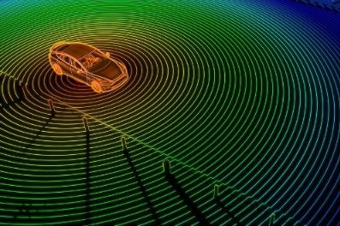
Fig.1 LiDAR sensing surroundings
Together with these three sensors and a camera we can gather information like speed of the car , proximity of the car in accordance to other objects in it’s surroundings, presence of any uneven terrain in proximity to the car, relative speed of neighboring vehicles and it’s trajectory, vibrations produced by the car while driving etc. and use these gathered information to our advantage(as in fig 1 and fig 2). It is basically a Level 1 semi-autonomous arrangement.
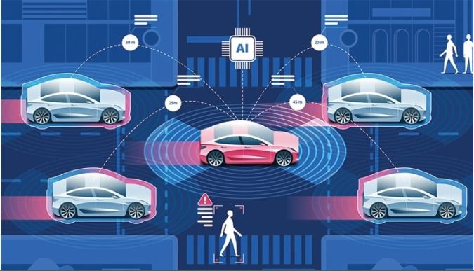
Fig.2 Proximity sensors covering up the blind spots created by LiDAR imaging depicted by the continuous circular region while the red shadow depicts the relative speed of the surrounding vehicles
Firstly, a 360-degree LiDAR sensing camera continuously gathers information about the area surrounding the vehicle and tell the system about any potholes or other obstruction in its trajectory which sometimes the camera can misjudge as shadows in the road. IMU informs the system about its current trajectory and speed which will help the system to take decision on whether to take partial control over the car or just alert the driver. Reading from proximity sensor and a small camera at the rear end of the car will help the driver while parking. Proximity sensors at the surface of the car will help covering up the blind spots created by the lidar imaging thus increasing the sensitivity and precision of the car.

Algorithm: Framework of curb detection.
Require:
Point clouds collected by LiDAR;
Ensure:
Step 1: Given input point cloud, select interested area;
Step 2: Calculate vector difference of adjacent points;
Step 3: Select curb-like points and filter out noises;
Step 4: Separate higher obstacles by comparing the height with a threshold;
Step 5: return Curb points.

After gathering all this information, the system can basically act in 3 modes. They are as follows:

MODE A:
When the system detects potholes or irregularities or obstruction on the road up ahead in the trajectory or maybe a traffic signal it then alerts the driver with a constant beeping noise describing the inattentive driver of the impending danger. It can even alert the driver of chances of rare ending someone while parking or while moving through small dingy roads which are quiet a common feature of Indian roads. The system can also keep track of cars running Infront of or back of the car and calculate the relative speeds to avoid any illegal overtaking and rash driving from the driver’s end. Images collected from the camera informs the driver continuously of traffic signals over a small display screen and also helps keep track of any road landform changes and construction sites and thus updating the map GPS systems continuously.
MODE B:
What happens when the car suddenly comes in close proximity to some other vehicle or animal on the road such that informing the driver about it is no longer a valid option for the system. The system then takes partial control over the vehicle controlling its speed while the driver can still steer out of it comfortably thus reducing the pressure on driver to control speed and direction and making some misjudgments and ultimately hitting the obstruction by limiting the controls provided to the driver.
In case the system detects a certain depression or elevation or any other irregularities in terrain on its trajectory it then again gains partial control over the speed of the vehicle for the sake of adaptive driving and comfort of suspension for the people sitting inside the terrain. In case it detects a traffic signal or a sharp turn ahead of it, it automatically turns the back light on and slows down the vehicle to a level so that the driver can comfortably make the turn. Thus, abiding and making sure that the driver follows proper traffic rules while driving.
MODE C:
This is where things get more interesting. What happens when a vehicle or a commoner suddenly approaches the vehicle from the other side of the road or cattle suddenly comes by and stops at the middle of the road or what happens or while changing lanes u suddenly encounter a vehicle coming from the opposite side. The System then momentarily takes entire control of the vehicle till the time the danger is totally out of the way because a system’s reaction time is far more superior to an individual’s reaction time in these kinds of situations. For the first case presented the system either momentarily stops the vehicle depending on the speed and distance of the vehicles approaching the driver from the rear end or honks and tries to take a different trajectory in order to avoid any collision. For the second case if any living obstruction comes at the middle of the road the system has to stop immediately and effectively and honk continuously till the obstruction is cleared.
These are mainly the three step control process that is going to take place in such semi-autonomous vehicles which although is nothing compared to what autonomous vehicles can provide but in the roads of India it is a really effective and economical way to deal with accidents and make driver’s journey as convenient and comfortable as possible. It will not only assist the driver with driving but also pave way for the advent of AVs in India because the main problem in India is the tendency of the drivers to not follow the traffic rules while driving and breaking the rules as and when necessary. Making these types of semi-AV systems compulsory in every vehicle will not only enforce the drivers to abide by the traffic rules but also highly decrease the amount of road accidents in India exponentially.
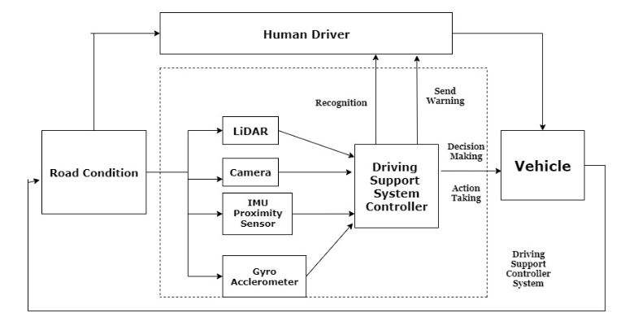
Fig.3 A simple flowchart depicting the control system
From fig 3, LiDAR sensor mainly captures a 360 degree image of the surrounding area of a certain field radius and transforms the whole image into a visible spectrum field rating where closer areas are depicted with high wavelength colors(such as red) and further areas covered with lower wavelength colors( such as blue or violet) as shown in the given diagram. Thus, a certain blue or dark area on a red spot will indicate a depression and a certain bright red spot on a fairly blue area will indicate a sudden elevation in the trajectory path which will indicate a certain anomaly in the road and the system gets ready to take action. When a car or a vehicle suddenly comes to close to the driver’s vehicle the proximity sensors generate high frequency signals to alert the system of an incoming danger and the system then analyses the proximity pattern of the certain vehicle and drives out of the way or if there is no way out then calculates the damage count on impact and deploys the safety bag accordingly to make the driver secure. The image sensor keep a look out for both front and back of the car for any possible collision and makes sure that the driver doesn’t brake any traffic law while driving and keeping the judgement of driver to change lanes in mind it makes sure and provide information to the driver about the presence of vehicles while lane shifting and overtaking. Fig 4 is a general undertaking of sensor network.
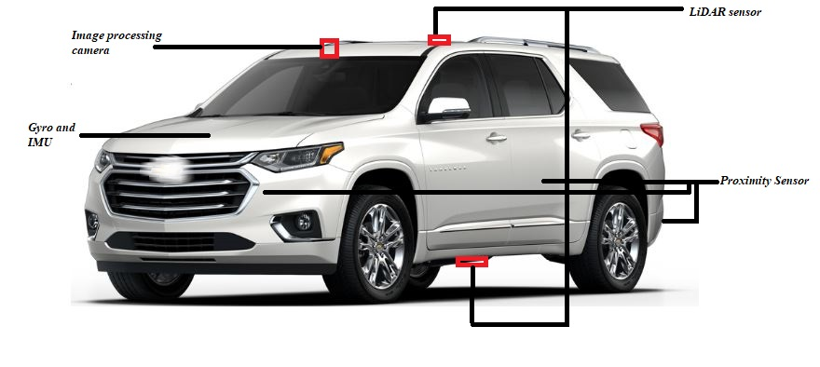
Fig.4 Sensor network diagram

RESULT ANALYSIS AND SIMULATION
After putting real life test and collecting data on pedestrians, trees, traffic signs, light poles etc. to make recognition data of different surroundings and environment we gather the following data as shown in fig 5 and fig 6 :
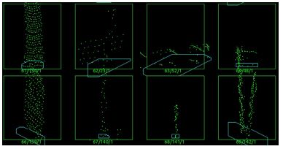
Fig.5 Some negative training examples including trees, traffic signs and light poles

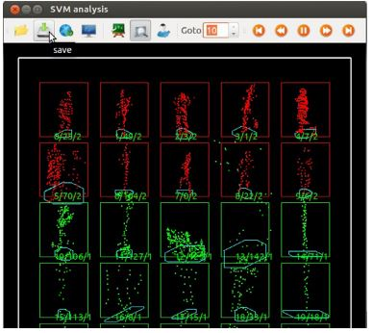

Fig.6 Some positive training examples, including pedestrians with or without bags, walking side by side. The upper left two pedestrians are within 20 m, while the distance from the upper right two pedestrians are larger than 20 m.

Fig.7 GUI for labelling and training

After recognizing and tracking pedestrians around the autonomous vehicle, pedestrian positions are then compared with curb positions (the calculation of curb positions will be presented in the next section), alarms will be generated if either of the following two conditions is satisfied:

Pedestrian is on road in front of autonomous vehicle

Pedestrian is tending to cross the road.
The second condition can be monitored by checking the positions and velocity directions of pedestrians who are close to curbs. In addition, we track all pedestrian candidates by applying nearest neighbor algorithm, the same pedestrian candidate is assigned an invariant ID, this ID exists until the candidate is lost. The recognized pedestrians are divided into two categories by comparing their positions with curbs’, i.e., on road and outside of road. If a candidate is classified to be a pedestrian in frame j, it will be classified to be pedestrian in the following frames j + 1, j + 2, . . . as long as the tracking is not interrupted. The reason of this is that most false positives are caused by objects outside of road due to their similar shapes to pedestrians, while on-road false negative needs to be avoided as much as possible, however, when on-road pedestrians become too close or too far from autonomous vehicle, only a few laser beams are irradiated on pedestrian, this may cause missing recognition of pedestrians (i.e., false negative), this is very dangerous for autonomous vehicles. By the aid of tracking results and curb detection results, the true positive rate has been improved a lot.

From fig7,The quantitative evaluation is carried out to verify the effectiveness of the pedestrian recognition and tracking algorithm proposed in this paper. 3D range data is collected by Velodyne 64 (mounted on top of an autonomous vehicle/LiDAR) in real urban environment, shows the autonomous vehicle equipped with Velodyne 64, Velodyne 16, IMU and Encoder etc. Two kinds of scenarios are chosen for the experiment, one scenario is that the autonomous vehicle is parked by the side of a crowded road, pedestrians are walking around, including those who are carrying briefcases or backpacks, walking side by side etc. Another scenario is that the autonomous vehicle is moving on the road, different pedestrians are walking/waiting on the sidewalk, or crossing the road in front of the autonomous vehicle.

TABLE 1:
Condition of the scenario when autonomous vehicle is parked by the side of the road.
Description Total N pos. N neg.
Training data 2770 608 2162
Evaluation data 10050 1380 8670

TABLE 2:
Condition of the scenario when autonomous vehicle is moving on the road.
Description Total N pos. N neg.
Training data 2282 328 1954
Evaluation data 6340 1020 5320

Tables 1 and 2 show conditions for training and evaluating in these two scenarios, respectively. Given Figs. show the corresponding ROC (receiver operating characteristic) curves, where the vertical and horizontal axes represent true positive rate and false positive rate, respectively. The dashed line is recognition result of classifier trained by SVM, while solid line is the result improved by tracking results. It can be seen that true positive rate is increased approximately 0.15 and 0.1 at the point where false positive rate is 0.02 for these two scenarios, respectively as shown in fig. 8 and fig. 9.
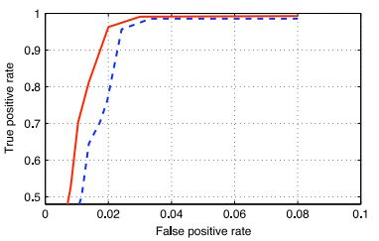
Fig.8 Recognition performance when autonomous vehicle is parked by the side of road. Dashed line is the recognition result of classifier trained by SVM, while solid line is the result improved by tracking results.
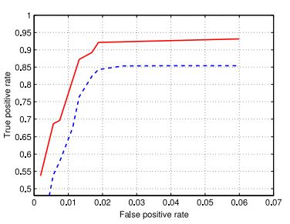
Fig.9 Recognition performance when autonomous vehicle is moving on road. Dashed line is the recognition result of classifier trained by SVM, while solid line is the result improved by tracking results.

conclusion
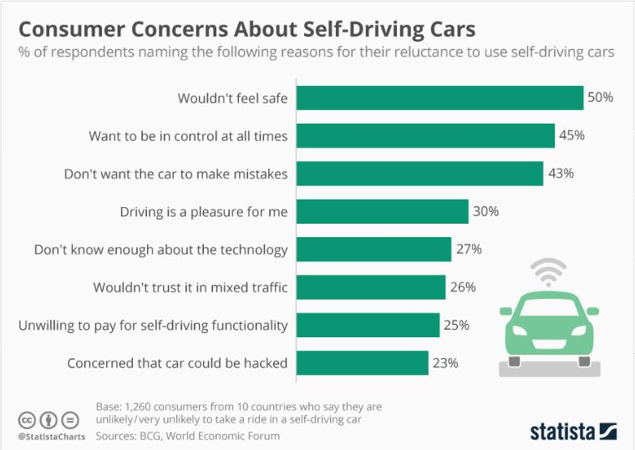
Fig.10 Consumer concern statistics
From fig 10 the above statistical chart, we can see that more and more people are concerned with trusting autonomous technology and its concepts. In order to get the masses interested and make them comfortable adopting AVs we need to first let them experience the lesser risky version(according to their thought process) of such vehicles so that they wont have to lose control over their vehicle at any time and anything that happens or may happen will be the sole responsibility of the individual driver driving the vehicle. Although with the advent of new generation it is expected that people will be having a more open view to these kind of safety vehicles and have a more day-to-day disciplined life while on the road.
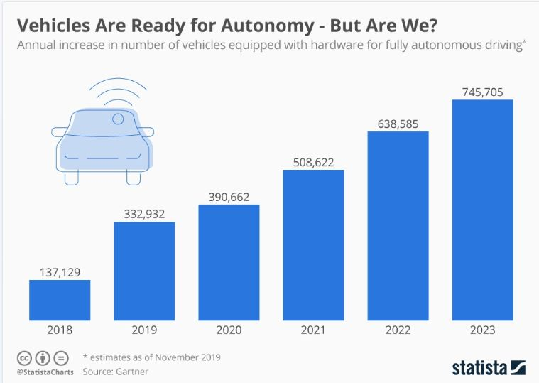
Fig.11 Vehicle autonomy growth
From the fig. 11 the above statistics shows that it is expected to have a gradual growth in the number of AVs and semi-AVs globally. While AVs create excitement in masses semi-AVs provide a more general and logical solution when it comes to Indian roads or roads of other countries where they are still in a developing stage and can’t afford to buy such expensive AVs.
If ride-on-demand services such as Uber & Ola have made a revolution in the idea of conveyance, self-driving vehicles are going to be the next renaissance shaking up the whole transportation industry. This new idea is on its way to become a multi trillion-dollar business — bigger than Amazon and Walmart combined. According to the World Economic Forum, this big leap in the auto industry will deliver $3.1 trillion annually by reducing number of crashes, need for emergency services, saving man-hours, cost of car ownership & also indirect savings from shorter commutes and less carbon emissions.
On top of that, there are endless design possibilities, once you eliminate the need for a steering wheel and a driver. Cars could be compact and egg-shaped or box-like mobile homes that can offer much more than mobility. Drastically different car design means drastically different roadways. The road itself could suggest a faster, safer route and smart devices — embedded in vehicles and infrastructure — would communicate on the fly to accommodate traffic.

.

References
- Wang, Heng, et al. "Pedestrian recognition and tracking using 3D LiDAR for autonomous vehicle." Robotics and Autonomous Systems 88 (2017): 71-78.
- Gao, Hongbo, et al. "Object classification using CNN-based fusion of vision and LIDAR in autonomous vehicle environment." IEEE Transactions on Industrial Informatics 14.9 (2018): 4224-4231.
- Wang, Liang, Yihuan Zhang, and Jun Wang. "Map-based localization method for autonomous vehicles using 3D-LIDAR." IFAC-PapersOnLine 50.1 (2017): 276-281.
- What is a LiDAR Sensor? (https://www.azosensors.com/article.aspx?ArticleID=1110
- https://www.google.com/search?q=lidar+sensor+images&rlz=1C1NDCM_enIN849IN849&sxsrf=ACYBGNQaty70k1WWonvw1Zs1AbAQZ4894w:1581945396824&tbm=isch&source=iu&ictx=1&fir=QLOb-eq3lLGkTM%253A%252CMHp7xx96_3KqtM%252C_&vet=1&usg=AI4_-kR71VT8DQDF41FpwGjmi5vGjf7NSw&sa=X&ved=2ahUKEwjA67nr1djnAhXTQ30KHa9vBPEQ9QEwBnoECAoQKQ#imgrc=ZIdu7dAKTGKXAM)-> 19/02/2020
- Inertial Measurement Unit Wikipedia (https://en.wikipedia.org/wiki/Inertial_measurement_unit)- [last accessed on 19/02/2020]
- Proximity sensor
(https://en.wikipedia.org/wiki/Proximity_sensor) [last accessed on 19/02/2020]
- Driverless cars face unique challenges on Indian roads (https://economictimes.indiatimes.com/industry/auto/driverless-cars-face-unique-challenges-on-indias-chaotic-roads/articleshow/59379769.cms?from=mdr) [last accessed on 19/02/2020]
- An introduction to automotive lidar (http://www.ti.com/lit/wp/slyy150/slyy150.pdf) [last accessed on 19/02/2020]
- Road condition monitoring prompting method, system and navigating instrument (https://patents.google.com/patent/CN102717753B/en) [last accessed on 19/02/2020]
- Why we need a meaningful comparison of vehicle autonomy (https://www.pluglesspower.com/learn/need-meaningful-comparison-vehicle-autonomy/) [last accessed on 19/02/2020]
- Autonomous Driving Explained - Levels, Safety Issues and Driverless Cars in India (https://www.news18.com/news/auto/autonomous-driving-explained-levels-safety-issues-and-driverless-cars-in-india-1886917.html) [last accessed on 19/02/2020]
- Driverless cars face unique challenges on India's chaotic roads (https://www.google.com/search?q=disadvantages+of+autonomous+vehicles+in+indian+roads&rlz=1C1NDCM_enIN849IN849&oq=disadva&aqs=chrome.1.69i57j35i39j0l6.5026j0j7&sourceid=chrome&ie=UTF-8) [last accessed on 19/02/2020]
- Driverless cars; the benefits and disadvantages (https://digileaders.com/driverless-cars-the-benefits-and-disadvantages/) [last accessed on 19/02/2020]
- https://yourstory.com/mystory/self-driving-cars-advantage-disadvantage-h4mvecdv9g
- Self-driving cars – Advantage & Disadvantage (https://towardsdatascience.com/self-driving-car-on-indian-roads-4e305cb04198) [last accessed on 19/02/2020]
- Self-driving cars challenges obstacles (https://www.vox.com/2016/4/21/11447838/self-driving-cars-challenges-obstacles) [last accessed on 19/02/2020]
- Concerns about self-driving cars (https://www.statista.com/chart/5950/concerns-about-self-driving-cars/) [last accessed on 19/02/2020]
- Vehicles Are Ready for Autonomy - But Are We? (https://www.statista.com/chart/20091/annual-increase-in-number-of-vehicles-equipped-with-hardware-for-fully-autonomous-driving/) [last accessed on 19/02/2020]
- Self-Driving Car on Indian Roads (https://towardsdatascience.com/self-driving-car-on-indian-roads-4e305cb04198) [last accessed on 19/02/2020]

